Style

Bioghist, Scope and contents
Begin the bioghist with 1-2 short, clear sentences identifying name, dates, nationality, and importance (similar to Wikipedia). For example:
Alphonse Marie Louis de Prat de Lamartine (1790-1869) was a French writer, poet and politician.
Oronzio Maldarelli (1892-1962) was an Italian-born American sculptor and teacher. He was known for his figurative works and taught at the Beaux Arts Institute of Design in New York and at Columbia University.
If nothing is known about the person, put boilerplate statement:
Nothing is known of I. Mains beyond the information given in the collection materials. He was a resident of New York Mills, New York.
Remember that our finding aids are indexed by Google etc and contributed to ArchiveGrid, so bioghists must be self-contained – we cannot rely on people seeing them in an SU or SCRC context.
In the Scope and contents, discuss each series in the collection, in the order they appear in the inventory and using the exact same title as appears in the inventory section. Bold the name of the series the first time it occurs in the discussion.

Capitalization and punctuation
Any narrative text that has complete sentences (e.g., the bioghist, the scopecontent) should use standard capitalization and punctuation.
<abstract>should NOT be complete sentences and should not have ending punctuation, for example:
<abstract>photographs, candid and posed</abstract>
If the description needs to be longer, with several sentences, use <scopecontent>
In the inventory section, capitalize only the first letter of the first word of <unittitle>s unless it’s a proper name, for example:
<unitititle>Family photographs</unittitle>
<unitititle>Correspondence, incoming</unittitle>
<unitititle>Scrapbooks and photo albums</unittitle>
This is true for titles of books, magazines, articles, etc – capitalize only the first letter of the first word, unless it’s a proper name, for example:
The jungle book.
All quiet on the western front.
Don’t add punctuation to extent, e.g. “3 folders” If coded correctly, the parentheses are automatically added.
ALL terms in <controlaccess> MUST have ending punctuation EXCEPT for our pre-set specialized local subjects (see below). Acceptable ending punctuation marks are as follows: . ) - ! ?
ALL <subject> terms taken from LC MUST have <space>--</space> separating the subfields. For example:
Syracuse (New York) -- History.
Civil rights movements -- United States.
BEWARE OF MS WORD! It will automatically change your double dashes to a long single dash, and/or change straight apostrophes and quotes to curly apostrophes and quotes. Also BEWARE of copying/pasting from online sources, as they may also have problematic characters. Either disable the autocorrect in Word, or encourage people to work in Notepad or a plain text editor.

Bolding and italics
Do not manually bold subseries titles down in the inventory. If they are correctly encoded, the style sheet will take care of that. Do not bold series titles in Arrangement section.
Do bold titles of series in the ScopeContent, as they are discussed. For example:
Correspondence contains…
Memorabilia contains…
At the end of the collection are a few Audiorecordings…
Titles of books, articles, etc. may be italicized in narrative sections of the finding aid, but if they serve as the title of a folder or subsection down in the inventory, they should not be italicized (it can mess with automated searching and ordering).

Multiple folders
If you have a bunch of folders that contain the same thing, there’s no need to list them all individually. For exampe, you could do this:
Box 1 Correspondence, 1962
Box 1 Correspondence, 1963
Box 1 Correspondence, 1964
But there is no need to. It’s simpler and shorter to merge them and list the number of folders, like so:
Box 1 Correspondence, 1962-1964 (3 folders)
Remember also that a date by itself can’t be a title, so this is incorrect:
Correspondence
Box 1 1962-1968
Box 2 1969-1974
It should be either like this:
Box 1 Correspondence, 1962-1068
Box 2 Correspondence, 1969-1974
Or like this:
Correspondence
Box 1 [General] 1962-1968
Box 2 [General] 1969-1974

LCNAF and LCSH
<*name> and <subject> terms should come from LC, if at all possible. You can search LC at http://authorities.loc.gov . Be sure to only choose terms that have the “Authorized heading” logo in the first column and “Library of Congress subject headings” in the third column.
If it says “References” click to see the correct preferred term. If it says “Authorized & References” it’s OK to use the term, but it’s a good idea to click through to see if there’s another more specific term.
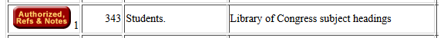
If it says “Notes” it’s a good idea to click through and read the scope notes to find out more about how the term is used. For example, “students” has the following scope note:
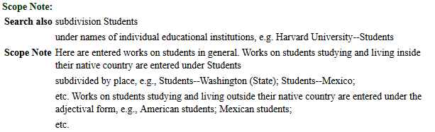

AAT
<genreform> terms should always come from the Art & Architecture Thesaurys (AAT), http://www.getty.edu/research/tools/vocabularies/aat/index.html . Choose terms that describe the physical item. For example, “VHS” would be an appropriate term to use for <genreform> but “video (art discipline)” would not.
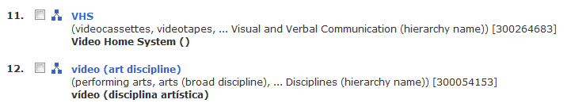
You can do a general search for a rough match, then by clicking the little hierarchy logo, explore broader, narrower, and related terms:
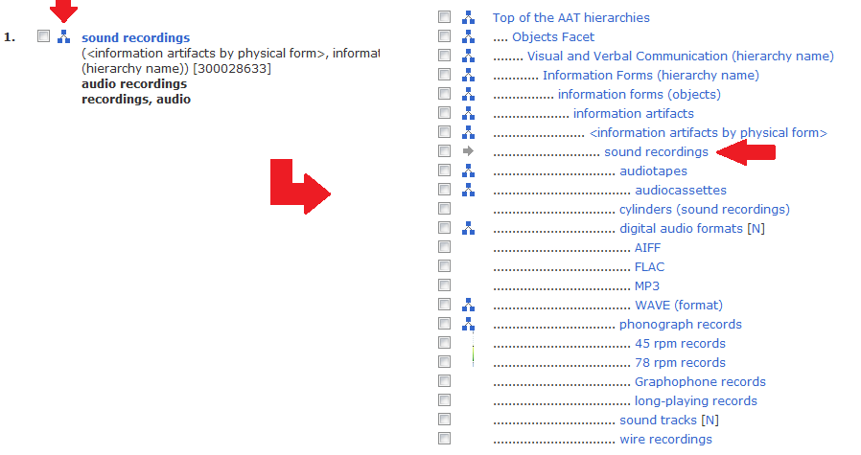

Terms should always start with a capital letter. If the term has parenthetical information, that must be included.
Examples:
<genreform>Sound recordings.</genreform>
<genreform>Photographs.</genreform>
<genreform>35mm (photographic film size)</genreform>
<genreform>Clippings (information artifacts)</genreform>
Like <*name> terms, <genreform> terms must always end in some form of punctuation, usually a ) or a . But don’t use more than one punctuation mark at then end. For example, this is NOT correct:
<genreform>Collages (visual works).</genreform>
It should be this:
<genreform>Collages (visual works)</genreform>

Coding

Required sections
Our finding aids adhere to DACS standards, which means that certain sections are required even if we don’t have any information. The following sections should ALWAYS be present in a finding aid:
- Title
- Inclusive dates (if it’s unknown, take your best guess with “circa”)
- Extent
- Abstract
- Languages of the material (<langmaterial>)
- Bioghist (if nothing is known, see above for example text)
- Scope and content
- Arrangement (can be as short as “Material is arranged alphabetically by type or title.”)
- Access restrictions and use restrictions (boilerplate text is present in the EAD template)
- <controlaccess> terms, at least one or two
- Preferred citation
- Acquisition information (if it’s unknown, then say “Unknown”)
If any of the collection has been digitized or microfilmed, be sure to note this in the “Alternate Forms Available” section. Provide a link, if appropriate.
If any material has been removed from the collection and sent to Rare Books for cataloging, be sure to note this in the “Separated Material” section.

Change record
The purpose of this information is to allow a returning researcher to know if anything has changed significantly since they were last here. (I also use these to double check what changed when I do our regular finding aids uploads, so it helps me keep tabs on things too.)
If you update a finding aid in any substantive way, you must add an <item> to the <revisiondesc> at the top. The information should be in the following format: date – change (initials) For example:
23 Mar 2017 - folder added in box 481 (PB)
18 Jan 2017 - audio recordings inventory corrected (PJM)
Only significant changes need a change note. For example if you fix a typ (“yuo” “you”) or update the controlaccess terms, it isn’t necessary to add a change description. However, if additions were processed into the collection, or box numbers changed, or descriptions were significantly expanded, or an important error was corrected in the bioghist, those things should get a change note.

Local subjects
Every finding aid should have one or more relevant local subjects. These are very very important – they match up with our collection areas here https://library.syr.edu/scrc/collections/areas/index.php and feed into the “Subject Strengths” facet in our finding aids search here http://scrc.syr.edu .
For SCRC finding aids, the templates do not include any local subjects, so you must add them yourself.
For Pan Am and SUA, the “core” local subjects are included in the template. Others will need to be added manually.
Local subject headings should always be copied from your respective lists, to ensure that spelling, punctuation, etc. is identical. Don’t guess, don’t do it from memory:
G:\LIB\Special Collections\Digital Projects\EAD\notes\standard_inventory_notes\local_subjects.txt
G:\LIB\Archives\PROCESSING\EAD\local_subjects_sua_pa.txt
ONLY these predefined <subject> elements should have source set to local, that is: <subject source=”local”>.
ALL OTHER <subject> elements should have source set to lcsh, that is: <subject source=”lcsh”>

Links
Links from one folder to another within a finding aid, use <ref>
<c02><did><unittitle>Clemens, Samuel.</unittitle>
<note><p>See <ref target="twma">Twain, Mark</ref>.</p></note>...
...
<c02 id="twma"><did><unittitle>Twain, Mark</unittitle>...
...
Links from one finding aid to another, use <archref> (note slight difference between SCRC and SUA/PA103)
SCRC: See also the <archref href="../h/huntington_ah.htm">Anna Hyatt Huntington Papers</archref>.
SUA/PA103: See also the <archref href="pa103_l_mcclune_andrew.htm">Andrew McClune Papers</archref>.
Links from a finding aid to an external site or document (not belonging to SU), use <extref> with full URL:
Additional Mike Wallace interviews are held by the <extref href="http://www.hrc.utexas.edu/collections/film/holdings/wallace">Harry Ransom Center</extref>.
Links from a finding aid to a book in the catalog, use <ref> with BIBID. If the element is left empty, it will produce the default clickable text “View catalog record”.
<p>A copy of Cruses's book, <emph render="bold">Jen Cruse Antique Comb Collection</emph> is available in the Rare Books collection: <ref role="bibid" href="4116393"/>.</p>
<p>A copy of Cruses's book, <ref role="bibid" href="4116393"><emph render="bold">Jen Cruse Antique Comb Collection</emph></ref>, is available in the Rare Books collection.</p>
To insert an image, for example in a bioghist, use <extptr> with file name:
<extptr href="lorenzo.jpg" actuate="onload" show="embed" altrender="center" role="image/jpg" title="Lorenzo House, Cazenovia, New York" />
<extptr href="world_airways_001.jpg" actuate="onload" show="embed" altrender="right" role="image/jpeg" title="Pan Am Logo"/>
Always include the title attribute in extptr links for accessibility compliance.

